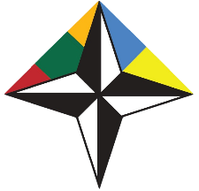

EMBASSY OF THE REPUBLIC OF LITHUANIA IN UKRAINE
NATO CONTACT POINT EMBASSY 2015-2016

Euroatlantic Security Policy Day

Mariupol, Ukraine • 6 April 2016
Venue: Mariupol State University, Budivelnikiv ave, 129 а

DRAFT PROGRAMME

6 April, Monday

09:00-09:30 Registration, morning coffee
09:30-09:45 Opening of the event.
10:00-12:00 Session 1

- Changing global security environment. What are the challenges and how to approach them?

- Euroatlantic security – a club of 28? What is NATO and what is its purpose in the contemporary world? Where is NATO presently active ?

12.00-13.00 Lunch break
13:00-14:45 Session 2

- NATO – Ukraine Distinctive partnership: what does it mean and what does it stand for?

- How does NATO work? Main formats, decision making, rules of work in NATO.

14:45-15:00 Conclusions

