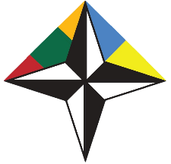

EMBASSY OF THE REPUBLIC OF LITHUANIA IN UKRAINE
NATO CONTACT POINT EMBASSY 2015-2018

Euro-Atlantic Youth Security Forum

Ivano-Frankivsk, Ukraine • 26-28 April 2017
Venue: Vasyl Stefanyk Precarpathian National University

DRAFT PROGRAMME

26 April, Wednesday
Arrival of the participants
19:00 Ice-breaker event

27 April, Thursday
09:00-09:30 Registration, morning coffee
09:30-09:45 Opening of the Forum
09:45-13:00 Session 1: “Building the Euro-Atlantic Security”

Topics:
- Changing global security environment. What are the challenges and how to approach them?
- Hybrid warfare
- Euro-Atlantic security – a club of 28? What is NATO and what is its purpose in the contemporary world?

13.00-14.00 Lunch break
14:00-17:00 Session 2: “NATO – Ukraine Distinctive partnership”

Topics:
- Ukraine’s role in the Euroatlantic security
- NATO – Ukraine Distinctive partnership: what does it mean and what does it stand for?
- How does NATO work? Main formats, decision making, rules of work in NATO. Setting the ground for tomorrow’s simulation.

18:00 Dinner

28 April, Friday

09:00-12:00 Simulation 1: “How does NATO work: meeting of the North Atlantic Council”

12.00-13.00 Lunch break
13:00-14:30 Simulation 2: “NATO-Ukraine Commission meeting”

14:30-15:00 Conclusions of the Forum

