Please take note of instructions on how to fill 6. Project Estimate in the Project application form. Integrated Microsoft Excel table can be opened:
Right Mouse button -> Worksheet object -> Open
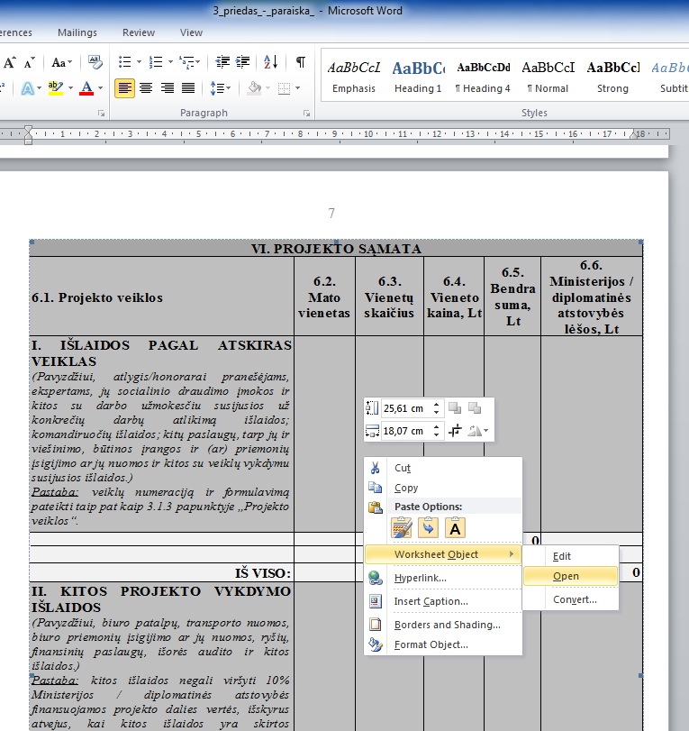

After the completion of the Project Estimate, save it in a separate file of Microsoft Excel and print it. (Please have in mind numeration of a whole Project Application – all pages of the Project Application have to be numerated consecutively.)
