Are you interested in security policy?
Are you studying in Kharkiv, Sumy, Donetsk or Luhansk regions?
Are you active and communicative?
Do you want to know more about Euroatlantic security?
Do you understand and speak English?

All „Yes“?!
Then you SHOULD APPLY for the
Euroatlantic Youth Security Forum!

When? November 17-18, 2015
Where? Kharkiv V. N. Karazin National University
How to apply? Go to http://ua.mfa.lt/ and fill in the application form!
Deadline for application – October 26, 2015
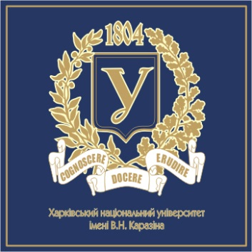
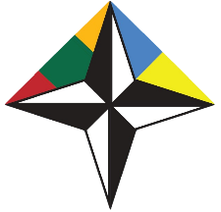
Organized by:

EMBASSY OF LITHUANIA IN UKRAINE
NATO CONTACT POINT EMBASSY 2015-2016

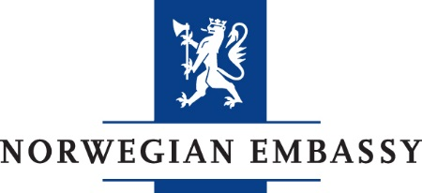
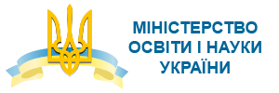
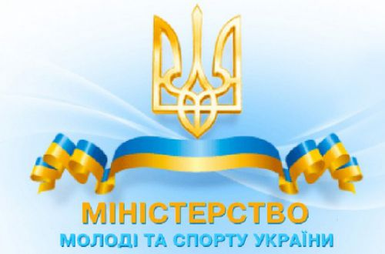
Supported by:

Note! The organizers will cover meal costs for all the participants and provide accommodation for students who are not resident in Kharkiv.
More information, programme and details on http://ua.mfa.lt/

